Name: A. F. M. RAFIUL HASSAN

ID: 22-47048-1

Group: 4

**The Blink Test**

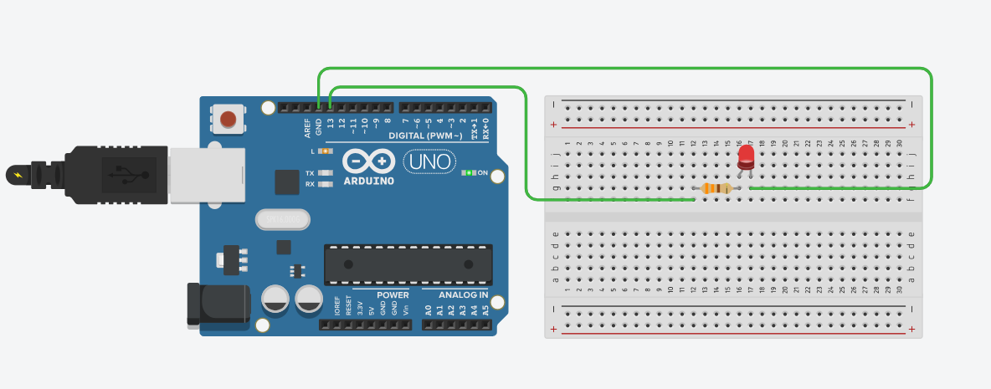

**Traffic Control System**

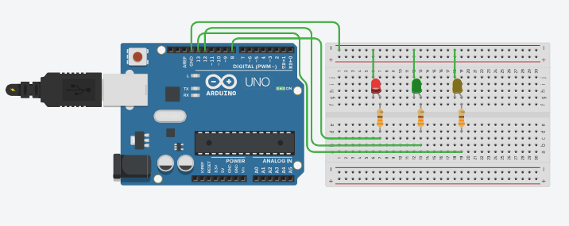

Red Light is ON

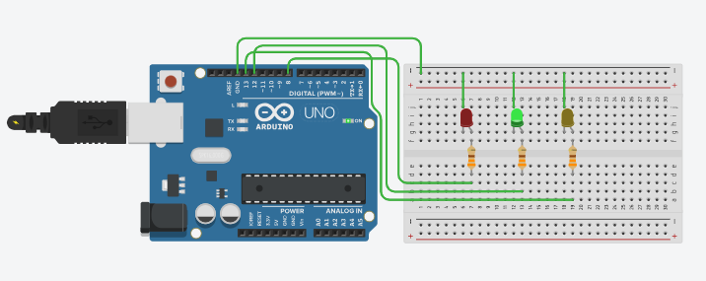 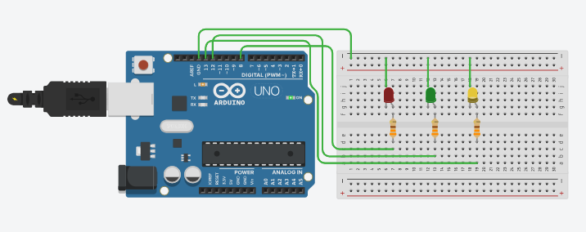

Green Light is ON Yellow Light is ON